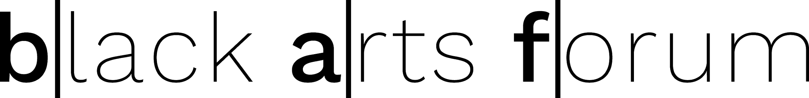

CREATE PROGRAMME
Creative Renewal Enterprise, Arts Training & Empowerment

Are you at a crossroad or dead-end in your practice? Are you looking for inspiration and support? Join a new hub of artists in North Birmingham to deliver a range of arts activities and events.

Black Arts Forum delivers interactive, thought-provoking sessions to support a range of artists to take their ‘next steps’. Based on our mini-series, CREATE Phase II, we will deliver appropriate support at our Arts Hub at Grosvenor Road Studios in Birchfield, North Birmingham.

We want to offer support to both emerging and established artists, working with a range of professionals, partner organisations and funders who will share their expertise and knowledge, to support your CPD. We will offer practical, tangible routes to taking those next steps.

Please complete and return the form below to register your interest and we’ll do the rest.

Looking forward to hearing from you.

Carol Pemberton & Pauline Bailey
Black Arts Forum
www.blackartsforum.co.uk

Please complete and sent this form to info@blackartsforum.co.uk
NAME __________________________________________________________
ART FORM ____________________________________________________
TICK AS RELEVANT
I am interested in:
- Effective professional practice development [ ]
- Product, Markets and Distribution/Branding [ ]
- Mentoring, funding and support networks [ ]

For further information, contact Pauline or Carol on: email the above
Address.

